

Commercial Non-Residential Multi-Peril General Tips

Class Codes:

Many users have been confused as to how to locate a class code and description. You can locate a code/description a couple of different ways:
1)
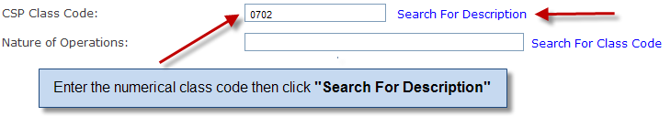
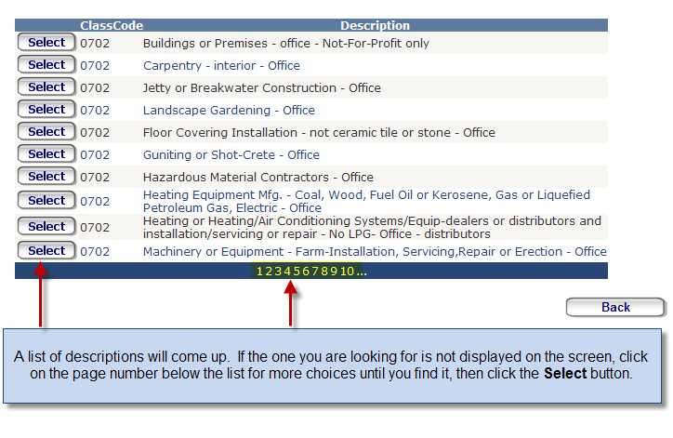
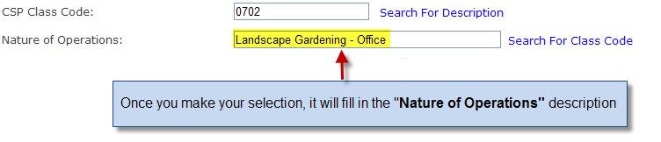
2) You can also do this in reverse. Instead of starting with the class code, start by typing a few letters of the description in the “Nature of Operations” box, then click “Search For Class Code”.
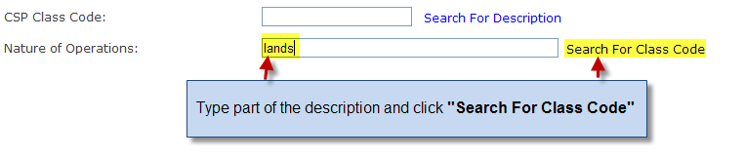
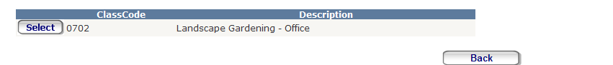

It is extremely important that you do not freeform type the description as it must match what is in the list in order to rate properly. For example, typing Landscaping Office and then attempting to rate would cause an issue with the final rate. Make sure to use the lookups. We have thousands of choices in the program.

Territory Lookup:

To look up a territory, type in the zip code. Once you have done that, finish the class code and nature of operations lookups. Then click on “Confirm Territory”.
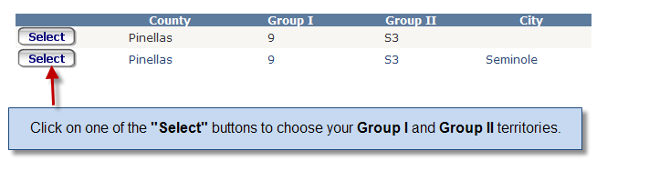

Specific Loss Costs:

If your risk is specific loss cost rated, you will need to enter the loss cost factors. Since we do not have access to the specific loss cost factors for a given property, you must obtain these from ISO and enter them in order to rate correctly.
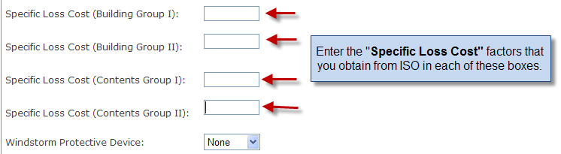

Keep this number handy for easy reference:
